Module Name: Login Page - Functional & UI Test Case
Test Case ID: TC_LOGIN_001
Webpage URL: https://opensource-demo.orangehrmlive.com/web/index.php/auth/login

Scenario ID: 1A
Scenario: Login with valid credentials
Test Steps:
- Open the OrangeHRM Login page
- Enter a valid username
- Enter a valid password
- Click on Login
Screenshots :
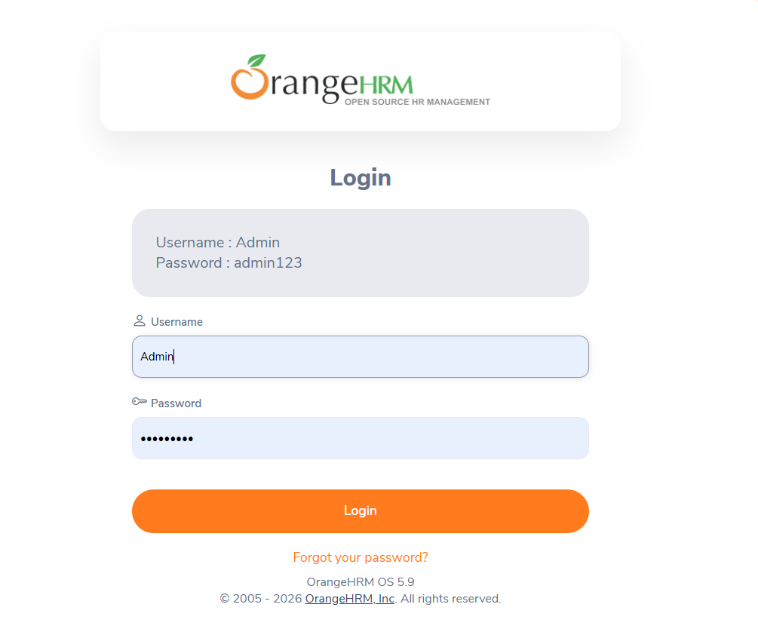
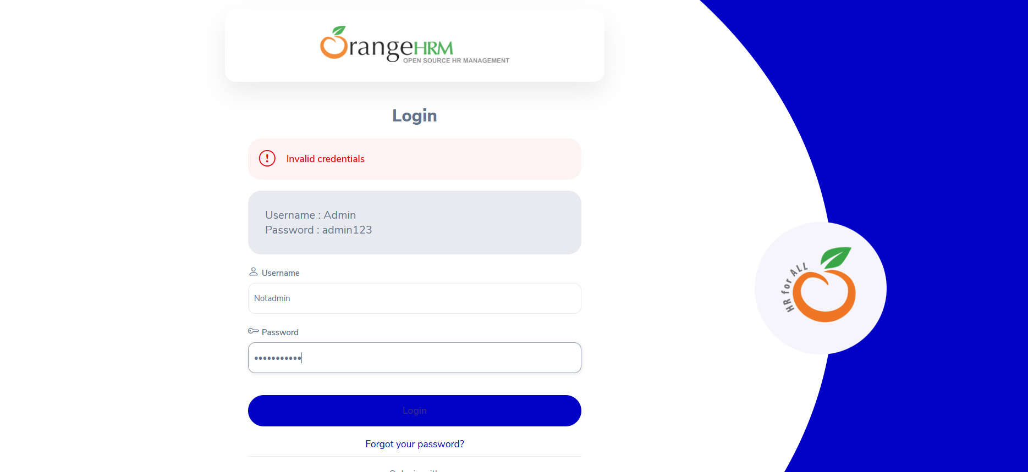

Scenario ID: 2A
Scenario: Login with invalid username
Test Steps:
- Open OrangeHRM Login page
- Enter invalid username
- Enter correct password
- Click on Login
Screenshots :
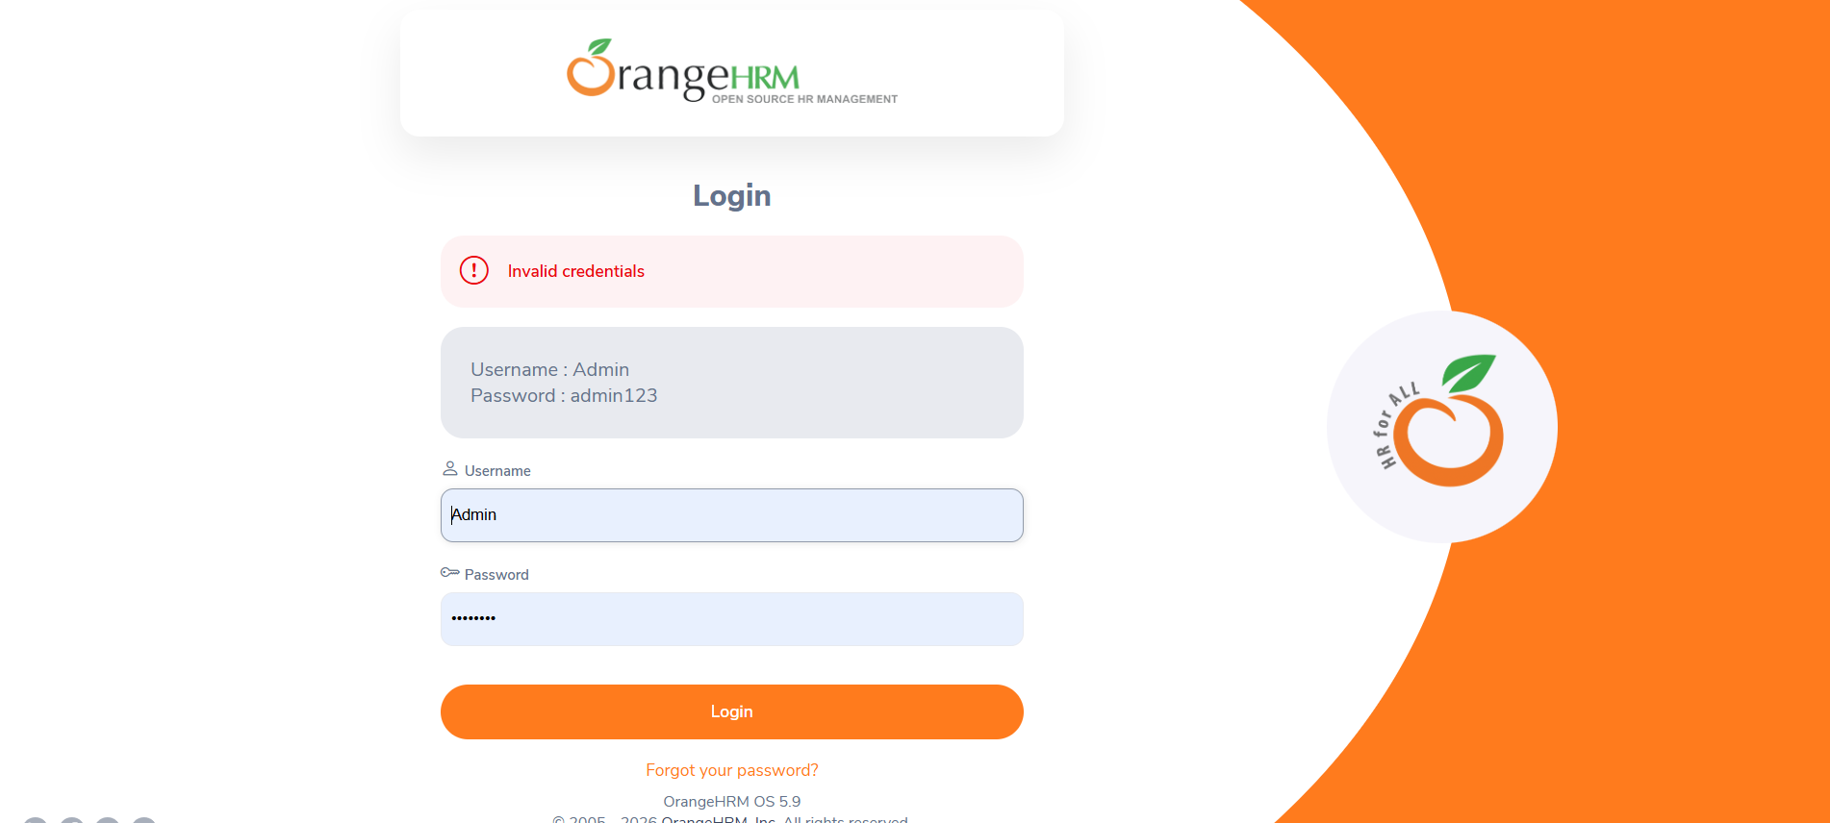

Scenario ID: 2B
Scenario: Login with invalid password
Test Steps:
- Open the OrangeHRM Login page
- Enter a valid username
- Enter an incorrect password
- Click on Login
Screenshots :
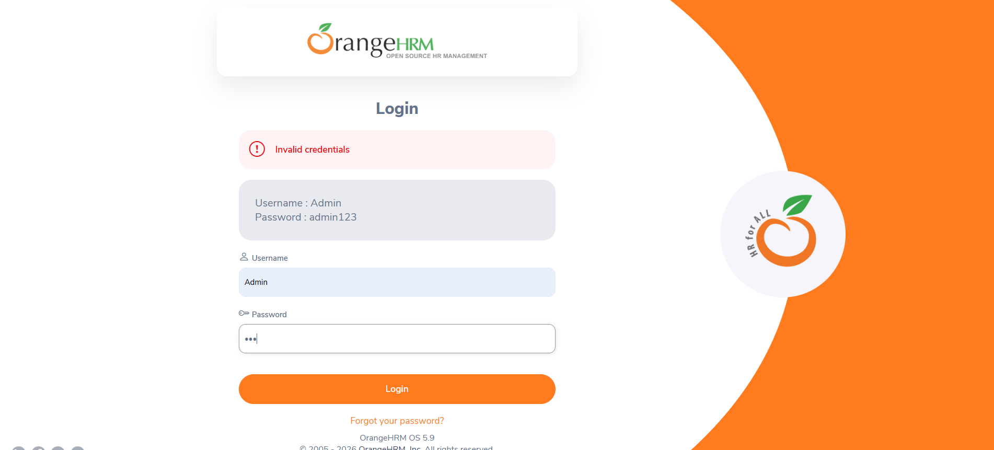

Improper validation & error message shown :
For invalid username :
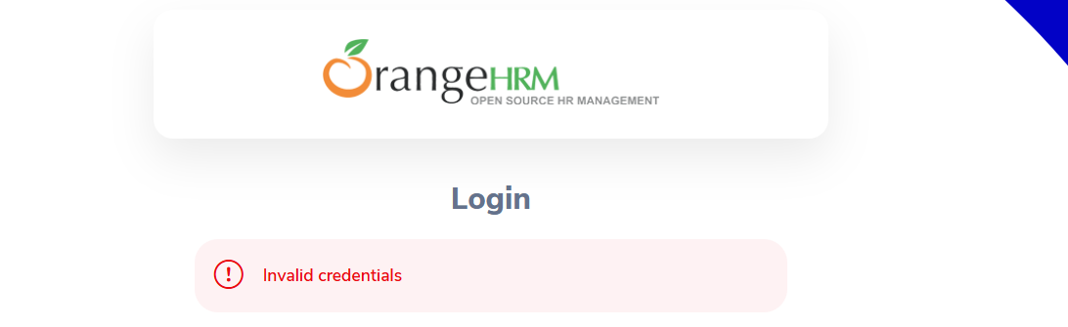

For invalid password :

For validation :

